**Faculty Profile Template**

1. **Basic Information**

* **Name**: Manoj Kumar Singh
* **Designation**: Assistant Professor
* **Department/School**: Computer Science and Engineering
* **Institution Name**: Shri Shankaracharya Institute of Professional Management & Technology, Raipur
* **Email ID**:msingh@ssipmt.com
* **Contact Number**: 9300251805
* **Photograph**: 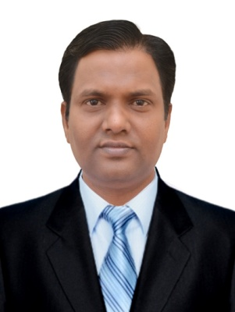 *(Passport-size, professional)*

1. **Educational Qualifications**

|  |  |  |  |
| --- | --- | --- | --- |
| **Degree** | **Specialization** | **Institution** | **Year of Completion** |
| UG | BSc(PCM) | Pt. Ravishankar Shukla University Raipur | 2000 |
| PG | M.Tech(CSE), MSc.(IT) | SATI Vidisha, RGTU, MPBU Bhopal | 2008,2005 |
| Ph.D. | Pursuing | CSVTU Bhilai |  |
| Others | *(if applicable)* |  |  |

1. **Teaching & Research Experience**

* **Total Teaching Experience**: 15 Yrs.
* **Industry Experience**: *(if any)*Nil
* **Research Experience**:Nil

1. **Courses Taught**

List of key UG/PG courses taught: **M. Tech (Information Security):** Introduction to Information Security and Intelligent Systems

**BE (CSE/IT) and MCA:** Computer Network, Data Warehousing and Mining, Theory of Computation, Compiler Design, Network Programming, Cellular and Mobile Computing, Software Engineering, Computational Science (Neural Network, Fuzzy Systems and Genetic Algorithm), Shell programming in Unix/Linux, Data Structures

* **Guided Several Projects to BE, M. Tech and MCA**

1. **Research Interests / Specialization**

* Key thematic areas or domains of expertise: Computer Network, Data Warehousing and Mining,

1. **Publications (Last 5 Years)**

* Journals (APA/IEEE format):Nil
* Conference Proceedings: 3
* Book Chapters / Books Authored:1

1. **Research Guidance**

|  |  |  |
| --- | --- | --- |
| **Level** | **Awarded** | **Ongoing** |
| Ph.D. |  |  |
| PG | 5 |  |

1. **Awards & Recognitions**

* Institutional / National / International: GATE Qualified in 2006

1. **Administrative Roles**

* Positions held (e.g., HoD, IQAC Coordinator, NAAC/NBA Committee Member): Nodal officer for Vocational Training at SSIPMT Raipur

1. **Professional Memberships**

* e.g., ISTE, IEEE, INFLIBNET, etc.: Nil

1. **Web Presence**

* Personal academic webpage / Google Scholar / ResearchGate / ORCID: Google Scholar, ORCID